Recap of what is left to do before moving servers:

1. "Clikability" on macs / my computer
   1. header not clickable, bought products but link to them is not clickable/downloadable, video not working, wish list editing and viewing not clickable, etc. There must be a root problem to all this, Vipin has ideas. Let me know if you need to borrow my computer to test.

2) AND / OR issue

3) Description not viewing properly on search results page and details page.

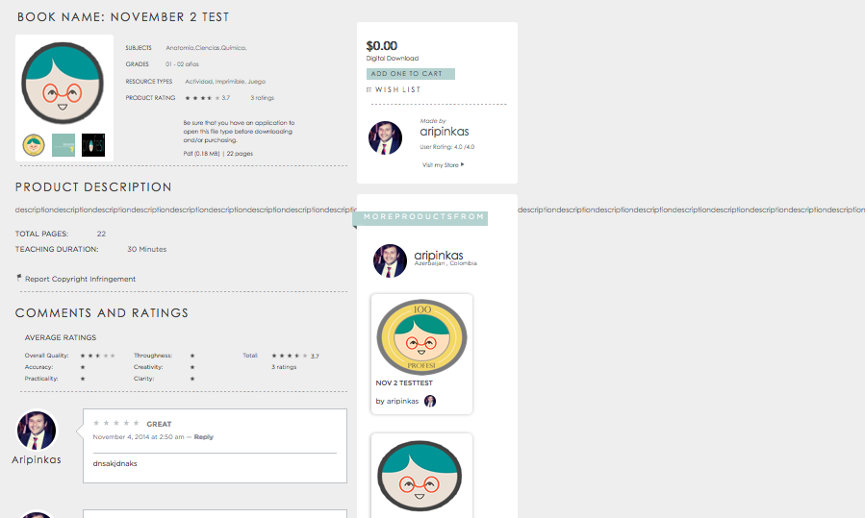

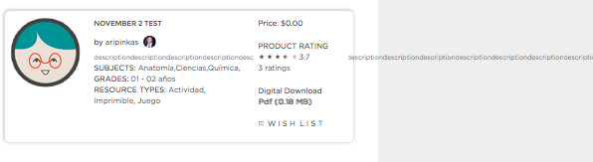

4) Sorting by ranking seems to be working…. Sometimes.

Vipin seems to know what is going on:

[2014-11-04, 1:32:41 AM] Vipin G: Rating working

[2014-11-04, 1:32:54 AM] Vipin G: But css change sort

[2014-11-04, 1:33:04 AM] Vipin G: It move products

[2014-11-04, 1:33:12 AM] Vipin G: By div

[2014-11-04, 1:33:31 AM] Vipin G: It told to poalo to fix it

5) Search results still have different sizes if you add more “resource type” and “subjects”.

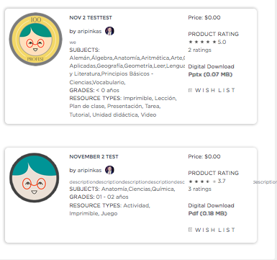

Lets do assign it like TPT does:

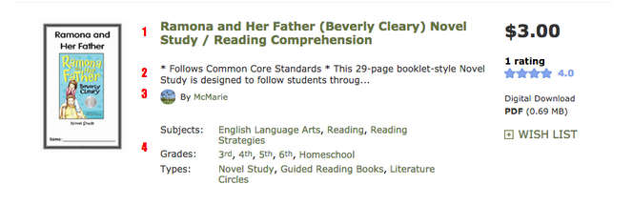

1. Title of Product – Max 2 lines, largest font
2. Description – Max 3 lines, smaller font than title
3. By: - 1 line, smallest font
4. Subject/grade/type – max 2 lines each, same font size as description

6) lets make registration pretty:

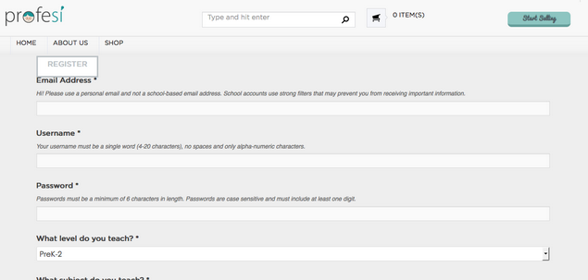

To be tested in after server switch:

* issue with emails not being sent
* test of real purchases
* orders tab for vendors